Contacts for the
New Hanover County
NAACP Parents’ Council

George Vlasits
Education Committee Chair, NHC-NAACP
gvlasits@gmail.com
910-465-8871

Amanda Boomershine
Spanish Language Parent Advocate
boomershinea@gmail.com

Karen Beatty
kbeatty09@att.net

Denise Yannone
President, SEPTA
denise.yannonesepta@gmail.com

Dorian Cromartie
Bandorianjc@gmail.com
910-512-2846

Karen Laughlin, Parent Educator
Exceptional Children's Assistance Center
klaughlin@ecacmail.org
(704) 578-5617

The New Hanover County Chapter of the NAACP
welcomes you!

Join Us in the Fight for Equality & Justice

The NAACP meets on the 4th Thursday of each month at 7:00 p.m.
Everyone is welcome!

Become a Member Today!

To join the NAACP, go to the link below. Please reference Chapter # 5424
www.naacp.org/membership/

To keep up with local NAACP activities:

email request to LeRon Montgomery president@nhcnaacp.org
visit our chapter webpage
https://nhcnaacp.org/

follow us on Facebook
New Hanover County NAACP

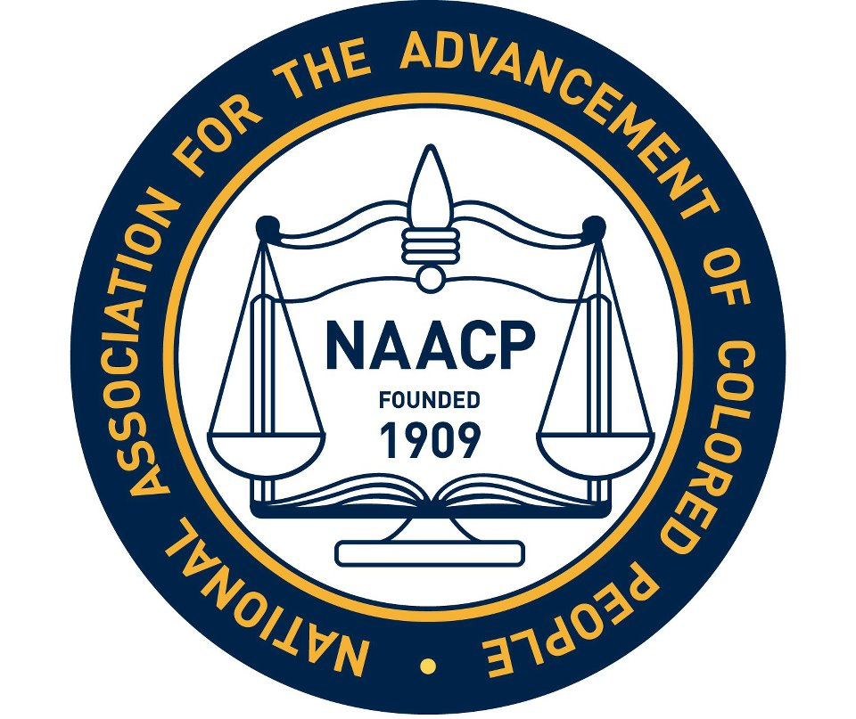

New Hanover County

NAACP

Parents’ Council

Advocating in support of our children, our community, and our future

WHO WE ARE

The NAACP Parents’ Council is an outreach effort of the New Hanover County NAACP. Our council, established in 2013, was created to empower parents to advocate for their children and play an active role in the education of their children.

The Council is made up of parents, educators and community members who share the goal of equitable and excellent education for all children.

OUR OBJECTIVES

The purpose of the Parents’ Council is to provide a forum through which interested citizens may offer assistance, guidance and support to NHCS students and parents.

We believe we can improve schools and students’ educational experiences by providing direct advocacy and information to families, encouraging parent involvement, and promoting policies that will foster fairness and best practices in our school system.

WHAT WE DO
- Empower parents, guardians and students by providing information about educational issues, policies and opportunities.
- Provide advice to families about school issues.
- Accompany families to school meetings to advocate for fair application of policies and practices.
- Provide a forum for information exchange.
- Collaborate with educators, community members & organizations sharing our goal of equitable and excellent education for all children.
- Host workshops and meetings about a variety of school issues and parent needs.
- Promote policies in New Hanover County Schools which insure equity and excellence in education.
- Link families to school personnel and programs that provide academic support and enrichment.

JOIN US AT OUR MONTHLY PARENT COUNCIL MEETING!

3rd Thursday of each month
7:00 PM. on Zoom
To join and keep up with our events
Email gvlasits@gmail.com

At our meetings, we:
- listen to concerns of parents about educational issues.
- share information.
- organize advocacy efforts.
- provide trainings.
- discuss issues that are relevant to students, parents and educators in NHCS.

TO CONTACT THE PARENTS’ COUNCIL:
- Email or call one of our listed contacts
- Visit our Facebook page: NAACP Parents’ Council of New Hanover County

